MongoDB Database
MongoDB is a powerful platform for managing NoSQL document-based databases. The cluster used in this project is hosted on MongoDB Atlas and runs on three AWS EC2 nodes, providing scalability and optimized performance. These compute nodes allow efficient querying and data extraction, even for very large datasets, in our case, approximately 24 million documents. This distributed setup enables MongoDB to handle big data management and high-volume data transfer effectively.
Unlike relational databases, MongoDB is nonrelational and stores data in a flexible, document-oriented format. Because our datasets contain long strings of text (such as user reviews and product descriptions), this data model is the most suitable choice. The data is stored in JSON Lines (JSONL) format, representing semi-structured, raw text data, which can be efficiently indexed and queried for analysis.
MongoDB Compass
MongoDB Compass is used to upload and inspect the datasets within the project’s MongoDB Atlas cluster. It provides a graphical interface for viewing documents, running queries, and exploring data structures stored in each collection.
In this project, Compass was used to verify that the merged datasets were successfully imported into the amazon_reviews database and stored under the “Electronics” collection. This interface also allowed the team to preview individual records.
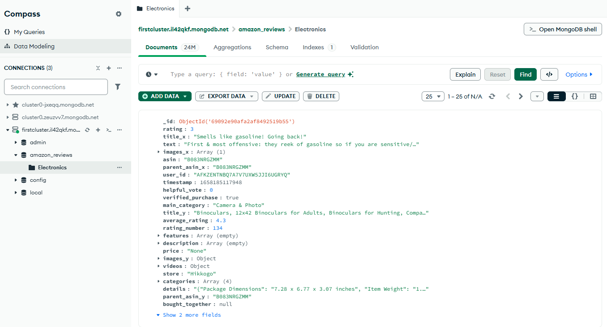

Data Integration
The two datasets, Electronics.jsonl.gz (containing user reviews) and meta_Electronics.jsonl.gz (containing product metadata), were merged using an inner join on the shared key asin (Amazon Standard Identification Number). The merge operation was performed in Python using pandas to ensure that only products appearing in both datasets were retained in the final dataset. The resulting merged dataset was then stored in MongoDB Atlas as the collection “Electronics” within the amazon_reviews database. A collection functions as a dataset in a document-oriented database, similar to a table in a relational database.
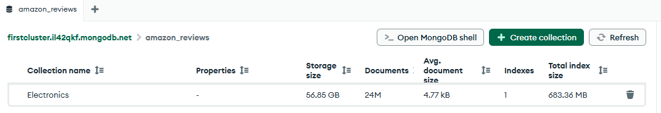

Database Engine
MongoDB Atlas is used as the cloud-based GUI for our NoSQL document database. Users can manage clusters, monitor, scale, and configure their deployments on this web console.

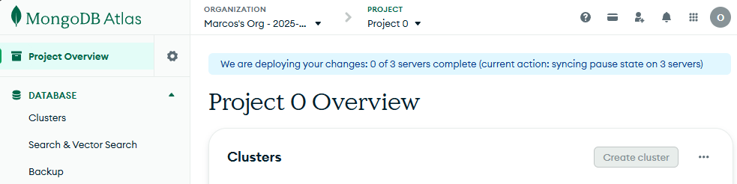

Users can monitor their operational metrics in the dashboard. This tool helps ensure the cluster is operating efficiently:

